GDD

for

Digital Elevator PO4_DGELV

Version 1.3 proposed

Prepared by /   
- Ahmed Refaat

- Donia Mohamed

- Marcelle Samir

Mar 8, 2020

Document Status

|  |  |  |  |
| --- | --- | --- | --- |
| **Version** | **Document Status** | **Author** | **Date** |
| V_1.3 | Proposed | Donia Mohamed  Ahmed Refaat  Marcelle Samir | Mar 8, 2020 |

Revision History

|  |  |  |  |  |  |
| --- | --- | --- | --- | --- | --- |
| **Name** | **Version** | **Author** | **Date** | **Change Description** | **Document Status** |
| GDD_DIGITAL_  ELEVATOR | V_1.0 | Donia Mohamed | Feb 26, 2020 | Initial creation of the GDD Document by adding  1)Naming convention  2)Document status  3)Revision history  4)table of signals  5)context diagram | Draft |
|  |  |  |  |  |  |
| GDD_DIGITAL_  ELEVATOR | V_1.0 | Ahmed Refaat | Feb 26, 2020 | Adding the static architecture ( layered architecture) | Draft |
| GDD_DIGITAL_  ELEVATOR | V_1.1 | Marcelle Samir | Feb 27, 2020 | Adding the static architecture ( components APIs) | Proposed |
| GDD_DIGITAL_  ELEVATOR | V_1.2 | Donia  Mohamed  Marcelle Samir | Feb 28,2020 | Adding some changes  1)changing the version of GDD  2)changing the Table of signals  3)changing the naming of context diagram | Proposed |
| GDD_DIGITAL_  ELEVATOR | V_1.2 | Marcelle Samir  Donia  Mohamed | Mar 5,2020 | 1) Editing the layered architecture  - removing PORT_Driver and OS  2) modifying APIs according to the review session  3) Adding the software features diagram | Proposed |
| GDD_DIGITAL_  ELEVATOR | V_1.3 | Marcelle Samir  Donia  Mohamed | Mar 8,2020 | 1) Removing ";" from the APIs  2)adding covers part to APIs  3) editing data type of some parameters from u32 to u8  4) Adding DIO_Init API  5) removing DIO_SetPinDir | Proposed |

Reference Table

|  |  |  |
| --- | --- | --- |
| **Ref. Document** | **Version** | **Document Status** |
| SRS_DIGITAL_ELEVATOR | V_1.4 | Proposed |
| HSI_DIGITAL_ELEVATOR | V_1.5 | Released |
|  |  |  |

Contents

Revision History 3

Reference Table 4

1. Introduction 6

1.1 Purpose 6

1.2 Project Scope 6

2. Software Context Diagram 1

3. Table of Signals 1

4. Software features 2

5. Static Architecture 3

- Layered architecture 3

- Component APIs 4

**1)** **DIO_Driver** 4

**2)** **Timer_Driver** 7

**3)** **Switch_Driver** 9

**4)** **LCD_Driver** 10

**5)** **Keypad_Driver** 1

**6)** **Buzzer_Driver** 1

**7)** **Motor_Driver** 1

**8)** **System_Control_unit** 1

**9)** **User_Registration_and_verification** 1

**10)** **Elevator_control** 1

# 1**. Introduction**

## 1.1 Purpose

This project aims at developing a Digital Elevator with lock system to be more secure and have specific functionalities.

The purpose of this document is to present a detailed description of the Digital Elevator System. It will explain the purpose, scope and features of the system, the interfaces of the system, what the system will do, the constraints under which it must operate.

## 1.2 Project Scope

This software system will be an Embedded System for a digital elevator. This system will be designed to secure the usage of the elevator and handle the movement of it. By having a limited number of resigned users with unique ID and entered password, we can secure the usage of the elevator. Using some developed buttons, the users can easily control the movement of the elevator.

# **2.** **Software Context Diagram**

# Table of Signals

|  |  |  |  |  |  |
| --- | --- | --- | --- | --- | --- |
| Signal | Type | Initial Value | Range of Values | Input/Output | Unit |
| Up_switch_status | Non-Constant | 0 | [0 /1] | Input | Volt |
| Down_switch_status | Non-Constant | 0 | [0 /1] | Input | Volt |
| On/Off_switch_status | Non-Constant | 0 | [0 /1] | Input | Volt |
| Pressed Key | Non-Constant | 0 | [0 /1] | Input | Volt |
| Motor_direction | Non-Constant | 0 | [0/1] | Input | Volt |
| System_status | Non-Constant | 0 | [0/1] | Input | Volt |
| Display_value | Non-Constant | 0 | [0-9] | Output | number |
| Curser_XPosition | Non-Constant | 0 | [0-15] | Input | number |
| Curser_yPosition | Non-Constant | 0 | [0/1] | Input | number |
| Buzzer_State | Non-Constant | 0 | [0/1] | Input | volt |

# **Software features**

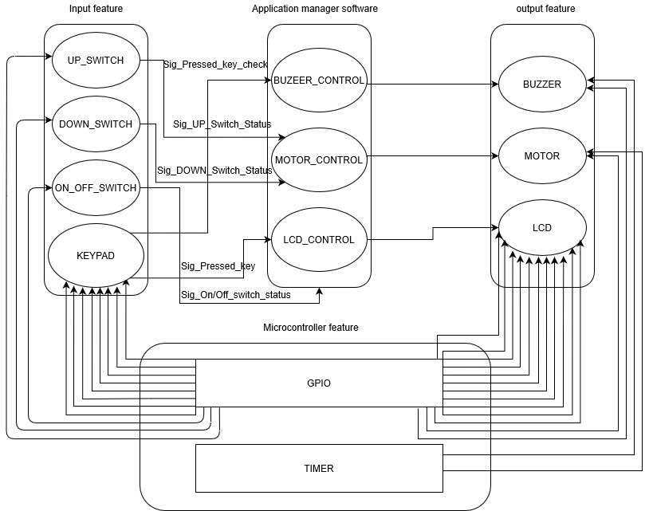

# **Static Architecture**

* 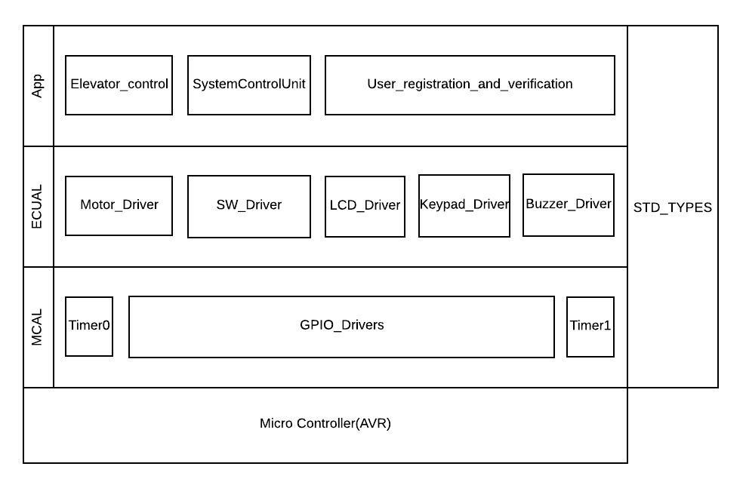Layered architecture

## Component APIs

1. **DIO_Driver**

|  |  |
| --- | --- |
| Req. ID | Req_DIGELV_GDD_001_V1.0 |
| Component Name | DIO_Driver |
| API Name | Error_Status DIO_Init(void) |
| Covers | NA |
| Return type | It’s u8 Error_Status, it returns E_OK or E_NO   |  |  | | --- | --- | | E_OK | 0 | | E_NOK | 1 | |
| Parameters type | This API doesn’t take any parameters, It sets the initial values of the predefined pins |
| Description | The functionality of this API to select its Direction (INPUT or OUTPUT) of the predefined pins, and also define if the INPUT pin is PULLUP or PULLDOWN |

|  |  |
| --- | --- |
| Req. ID | Req_DIGELV_GDD_002_V1.1 |
| Component Name | DIO_Driver |
| API Name | Error_Status DIO_SetPinValue(u8 Copy_u8Pin, u8 Copy_u8Value) |
| Covers | NA |
| Return type | It’s u8 Error_Status, it returns E_OK or E_NO   |  |  | | --- | --- | | E_OK | 0 | | E_NOK | 1 | |
| Parameters type | u8 Copy_u8Pin   |  |  | | --- | --- | | PIN16 | 16 | | PIN17 | 17 | | PIN18 | 18 | | PIN19 | 19 | | PIN20 | 20 | | PIN21 | 21 | | PIN22 | 22 | | PIN23 | 23 | | PIN24 | 24 | | PIN25 | 25 | | PIN26 | 26 | | PIN27 | 27 | | PIN28 | 28 | | PIN29 | 29 | | PIN30 | 30 | | PIN31 | 31 |  |  |  | | --- | --- | | PIN0 | 0 | | PIN1 | 1 | | PIN2 | 2 | | PIN3 | 3 | | PIN4 | 4 | | PIN5 | 5 | | PIN6 | 6 | | PIN7 | 7 | | PIN8 | 8 | | PIN9 | 9 | | PIN10 | 10 | | PIN11 | 11 | | PIN12 | 12 | | PIN13 | 13 | | PIN14 | 14 | | PIN15 | 15 |   U8 Copy_u8Mode   |  |  | | --- | --- | | LOW | 0 | | HIGH | 1 | |
| Description | The functionality of this API to select its value if it’s HIGH or LOW of a PIN by sending the pin number and the value as arguments |

|  |  |
| --- | --- |
| Req. ID | Req_DIGELV_GDD_003_V1.1 |
| Component Name | DIO_Driver |
| API Name | Error_Status DIO_GetPinValue(u8 Copy_u32Pin, u8 *Copy_u32Value) |
| Covers | NA |
| Return type | It’s u8 Error_Status, it returns E_OK or E_NO   |  |  | | --- | --- | | E_OK | 0 | | E_NOK | 1 | |
| Parameters type | u8 Copy_u8Pin   |  |  | | --- | --- | | PIN16 | 16 | | PIN17 | 17 | | PIN18 | 18 | | PIN19 | 19 | | PIN20 | 20 | | PIN21 | 21 | | PIN22 | 22 | | PIN23 | 23 | | PIN24 | 24 | | PIN25 | 25 | | PIN26 | 26 | | PIN27 | 27 | | PIN28 | 28 | | PIN29 | 29 | | PIN30 | 30 | | PIN31 | 31 |  |  |  | | --- | --- | | PIN0 | 0 | | PIN1 | 1 | | PIN2 | 2 | | PIN3 | 3 | | PIN4 | 4 | | PIN5 | 5 | | PIN6 | 6 | | PIN7 | 7 | | PIN8 | 8 | | PIN9 | 9 | | PIN10 | 10 | | PIN11 | 11 | | PIN12 | 12 | | PIN13 | 13 | | PIN14 | 14 | | PIN15 | 15 |   u8 *Copy_u8Value  it’s a pointer where the read value will be written in |
| Description | The functionality of this API to read the of a PIN by sending the pin number and port number as arguments and receiving the read value in a pointer. |

|  |  |
| --- | --- |
| Req. ID | Req_DIGELV_GDD_005_V1.0 |
| Component Name | Timer_Driver |
| API Name | Error_Status Timer0_voidSetCallBack(void (*Copy_pvCallBackPtr)(void)) |
| Covers | NA |
| Return type | It’s u8 Error_Status, it returns E_OK or E_NO   |  |  | | --- | --- | | E_OK | 0 | | E_NOK | 1 | |
| Parameters type | void (*Copy_pvCallBackPtr)(void)  it’s a pointer to void function to point to a function which will be run |
| Description | The functionality of this API to call a function to be run |

|  |  |
| --- | --- |
| Req. ID | Req_DIGELV_GDD_004_V1.0 |
| Component Name | Timer_Driver |
| API Name | Error_Status Timer_u8Init(void) |
| Covers | NA |
| Return type | It’s u8 Error_Status, it returns E_OK or E_NO   |  |  | | --- | --- | | E_OK | 0 | | E_NOK | 1 | |
| Parameters type | It doesn’t take any parameters |
| Description | The functionality of this API to make the hardware ready by applying standard sequence on it. |

1. **Timer_Driver**
2. **Switch_Driver**

|  |  |
| --- | --- |
| Req. ID | Req_DIGELV_GDD_006_V1.2 |
| Component Name | Switch_Driver |
| API Name | Error_Status GetSwitchState(u8 Copy_u8SwitchNum ,u8 *Copy_u8SwitchValue) |
| Covers | [Req_DIGELV_SRS_013_V1.0] |
| Return type | It’s u8 Error_Status, it returns E_OK or E_NO   |  |  | | --- | --- | | E_OK | 0 | | E_NOK | 1 | |
| Parameters type | u8 Copy_u8SwitchNum   |  |  | | --- | --- | | UP_SWITCH | 0 | | DOWN_SWITCH | 1 | | RESET_SWITCH | 2 |   u8 *Copy_u8SwitchValue  it’s a pointer where the read value will be written in   |  |  | | --- | --- | | SW_PRESSED | 1 | | SW_RELEASED | 0 | |
| Description | The functionality of this API to read the switch value by receiving the read value in a pointer. |

1. **LCD_Driver**

|  |  |
| --- | --- |
| Req. ID | Req_DIGELV_GDD_007_V1.1 |
| Component Name | LCD_Driver |
| API Name | Error_Status CLCD_voidInitialize(void) |
| Covers | NA |
| Return type | It’s u8 Error_Status, it returns E_OK or E_NO   |  |  | | --- | --- | | E_OK | 0 | | E_NOK | 1 | |
| Parameters type | It doesn’t take any parameters |
| Description | The functionality of this API to make the hardware ready by applying standard sequence on it. |

|  |  |
| --- | --- |
| Req. ID | Req_DIGELV_GDD_008_V1.2 |
| Component Name | LCD_Driver |
| API Name | Error_Status CLCD_voidGoToXVPos(u8 Copy_u8XPos, u8 Copy_u8YPos) |
| Covers | NA |
| Return type | It’s u8 Error_Status, it returns E_OK or E_NO   |  |  | | --- | --- | | E_OK | 0 | | E_NOK | 1 | |
| Parameters type | u8 Copy_u8XPos  this parameter takes the number of x position (range between 0 to 15)  u8 Copy_u8YPos  this parameter takes the number of y position, it has 2 options  (CLCD_U8_LINE_TWO (1) or CLCD_U8_LINE_ONE(0)) |
| Description | The functionality of this API to move the cursor to the desired position |

|  |  |
| --- | --- |
| Req. ID | Req_DIGELV_GDD_009_V1.2 |
| Component Name | LCD_Driver |
| API Name | Error_Status CLCD_voidWriteString(const char* Copy_pchString) |
| Covers | [Req_DIGELV_SRS_008_V1.1]  [Req_DIGELV_SRS_007_V1.1]  [Req_DIGELV_SRS_004_V1.1]  [Req_DIGELV_SRS_003_V1.1] |
| Return type | It’s u8 Error_Status, it returns E_OK or E_NO   |  |  | | --- | --- | | E_OK | 0 | | E_NOK | 1 | |
| Parameters type | const char* Copy_pchString  this parameter takes the text you want to display on the LCD |
| Description | The functionality of this API to print a text on the LCD |

|  |  |
| --- | --- |
| Req. ID | Req_DIGELV_GDD_010_V1.1 |
| Component Name | Keypad_Driver |
| API Name | Error_Status KEYPAD_GetPressedKey( u8 *Copy_u8KeyValue) |
| Covers | [Req_DIGELV_SRS_009_V1.1]  [Req_DIGELV_SRS_010_V1.1] |
| Return type | It’s u8 Error_Status, it returns E_OK or E_NO   |  |  | | --- | --- | | E_OK | 0 | | E_NOK | 1 | |
| Parameters type | u8 *Copy_u8KeyValue  u8 *Copy_u8SwitchValue  it’s a pointer where the read value will be written in   |  |  | | --- | --- | | KEY_PRESSED | 1 | | KEY_RELEASED | 0 | |
| Description | The functionality of this API to print a text on the LCD |

1. **Keypad_Driver**
2. **Buzzer_Driver**

|  |  |
| --- | --- |
| Req. ID | Req_DIGELV_GDD_011_V1.2 |
| Component Name | Buzzer_Driver |
| Covers | [Req_DIGELV_SRS_018_V1.0] |
| API Name | Error_Status SetBuzzerOn(u8 Copy_u8BuzzerNum) |
| Return type | It’s u8 Error_Status, it returns E_OK or E_NO   |  |  | | --- | --- | | E_OK | 0 | | E_NOK | 1 | |
| Parameters type | u8 Copy_u8BuzzerNum   |  |  | | --- | --- | | Buzzer_ONE | 0 | |
| Description | The functionality of this API to set the buzzer ON |

|  |  |
| --- | --- |
| Req. ID | Req_DIGELV_GDD_012_V1.2 |
| Component Name | Buzzer_Driver |
| API Name | Error_Status SetBuzzerOff(u8 Copy_u8BuzzerNum) |
| Covers | NA |
| Return type | It’s u8 Error_Status, it returns E_OK or E_NO   |  |  | | --- | --- | | E_OK | 0 | | E_NOK | 1 | |
| Paramete0rs type | u8 Copy_u8BuzzerNum   |  |  | | --- | --- | | Buzzer_ONE | 0 | |
| Description | The functionality of this API to set the buzzer OFF |

1. **Motor_Driver**

|  |  |
| --- | --- |
| Req. ID | Req_DIGELV_GDD_013_V1.1 |
| Component Name | Motor_Driver |
| API Name | Error_Status SetMotorOff(u8 Copy_u8MotorNum) |
| Covers | [Req_DIGELV_SRS_015_V1.0] |
| Return type | It’s u8 Error_Status, it returns E_OK or E_NO   |  |  | | --- | --- | | E_OK | 0 | | E_NOK | 1 | |
| Parameters type | u8 Copy_u8MotorNum   |  |  | | --- | --- | | Motor_ONE | 0 | |
| Description | The functionality of this API to set the Motor OFF |

|  |  |
| --- | --- |
| Req. ID | Req_DIGELV_GDD_014_V1.1 |
| Component Name | Motor_Driver |
| API Name | Error_Status SetMotorUp(u8 Copy_u8MotorNum) |
| Covers | [Req_DIGELV_SRS_013_V1.0] |
| Return type | It’s u8 Error_Status, it returns E_OK or E_NO   |  |  | | --- | --- | | E_OK | 0 | | E_NOK | 1 | |
| Parameters type | u8 Copy_u8MotorNum   |  |  | | --- | --- | | Motor_ONE | 0 | |
| Description | The functionality of this API to set the Motor Up |

|  |  |
| --- | --- |
| Req. ID | Req_DIGELV_GDD_015_V1.1 |
| Component Name | Motor_Driver |
| API Name | Error_Status SetMotorDown(u8 Copy_u8MotorNum) |
| Covers | [Req_DIGELV_SRS_014_V1.0] |
| Return type | It’s u8 Error_Status, it returns E_OK or E_NO   |  |  | | --- | --- | | E_OK | 0 | | E_NOK | 1 | |
| Parameters type | u8 Copy_u8MotorNum   |  |  | | --- | --- | | Motor_ONE | 0 | |
| Description | The functionality of this API to set the Motor Down |

1. **System_Control_unit**

|  |  |
| --- | --- |
| Req. ID | Req_DIGELV_GDD_016_V1.1 |
| Component Name | System_Control_unit |
| API Name | Error_Status SystemControl_Init(void) |
| Covers | NA |
| Return type | It’s u8 Error_Status, it returns E_OK or E_NO   |  |  | | --- | --- | | E_OK | 0 | | E_NOK | 1 | |
| Parameters type | This API doesn’t take any parameters |
| Description | The functionality of this API to call the Switch driver to initialize the predefined switchs pins. |

|  |  |
| --- | --- |
| Req. ID | Req_DIGELV_GDD_017_V1.1 |
| Component Name | System_Control_unit |
| API Name | Error_Status SystemControlReader( u8 Copy_u8SwitchNum ,u8 *Copy_u8SwitchStatus) |
| Covers | [Req_DIGELV_SRS_020_V1.0]  [Req_DIGELV_SRS_021_V1.0]  [Req_DIGELV_SRS_022_V1.0]  [Req_DIGELV_SRS_023_V1.0] |
| Return type | It’s u8 Error_Status, it returns E_OK or E_NO   |  |  | | --- | --- | | E_OK | 0 | | E_NOK | 1 | |
| Parameters type | |  |  | | --- | --- | | SWITCH_PRESSED | 1 | | SWITCH_RELEASED | 0 |   u8 Copy_u8SwitchNum  u8 *Copy_u8SwitchStatus  it’s a pointer carries the switch value   |  |  | | --- | --- | | UP_SWITCH | 0 | | DOWN_SWITCH | 1 | | ON_OFF_RESET_SWITCH | 2 | |
| Description | The functionality of this API to call the Switch driver to read it’s status if it’s Pressed or Released,  If ON_OFF_RESET_SWITCH is pressed a global variable will change to set the whole system on or off or reset the system |

|  |  |
| --- | --- |
| Req. ID | Req_DIGELV_GDD_018_V1.1 |
| Component Name | User_Registration_and_verification |
| API Name | Error_Status Keypad_LCD_Buzzer_Init(void) |
| Covers | NA |
| Return type | It’s u8 Error_Status, it returns E_OK or E_NO   |  |  | | --- | --- | | E_OK | 0 | | E_NOK | 1 | |
| Parameters type | It doesn’t take any parameters |
| Description | The functionality of this API to call the LCD driver, Keypad driver and Buzzer driver to initialize the predefined pins. |

|  |  |
| --- | --- |
| Req. ID | Req_DIGELV_GDD_019_V1.1 |
| Component Name | User_Registration_and_verification |
| API Name | Error_Status GettingMemberStatus(u8 *Copy_u8Members_Status) |
| Covers | [Req_DIGELV_SRS_005_V1.1] |
| Return type | It’s u8 Error_Status, it returns E_OK or E_NO   |  |  | | --- | --- | | E_OK | 0 | | E_NOK | 1 | |
| Parameters type | u8 * Copy_u8membersStatus  it’s a pointer carries the info of “if the caller is new or old member”   |  |  | | --- | --- | | NEW_MEMBER | 1 | | OLD_MEMBER | 2 | |
| Description | The functionality of this API to call Keypad driver to know if the caller is new member or old and call LCD driver to display this |

1. **User_Registration_and_verification**

|  |  |
| --- | --- |
| Req. ID | Req_DIGELV_GDD_020_V1.1 |
| Component Name | User_Registration_and_verification |
| API Name | Error_Status Member_Verification(u8 *Copy_u8Member_Password, u8 *Copy_u8Member_ID) |
| Covers | [Req_DIGELV_SRS_006_V1.1]  [Req_DIGELV_SRS_007_V1.1]  [Req_DIGELV_SRS_008_V1.1]  [Req_DIGELV_SRS_016_V1.0] |
| Return type | It’s u8 Error_Status, it returns E_OK or E_NO   |  |  | | --- | --- | | E_OK | 0 | | E_NOK | 1 | |
| Parameters type | u8 *Copy_u8Member_Password  it’s a pointer carries the member’s password  u8 *Copy_u8Member_ID  it’s a pointer carries the member’s ID |
| Description | The functionality of this API to call Keypad driver to get the member’s ID and Password and call LCD driver to display this, and if they are correct it calls Elevator_control to execute the desired action, and if the ID or password id incorrect for 3 times it calls the Buzzer driver to fire an alarm |

|  |  |
| --- | --- |
| Req. ID | Req_DIGELV_GDD_021_V1.1 |
| Component Name | User_Registration_and_verification |
| API Name | Error_Status Member_Registration(u8 *Copy_u8Member_Password, u8 *Copy_u8Member_ID) |
| Covers | [Req_DIGELV_SRS_006_V1.1]  [Req_DIGELV_SRS_009_V1.1] [Req_DIGELV_SRS_011_V1.1]  [Req_DIGELV_SRS_012_V1.1] |
| Return type | It’s u8 Error_Status, it returns E_OK or E_NO   |  |  | | --- | --- | | E_OK | 0 | | E_NOK | 1 | |
| Parameters type | u8 *Copy_u8Member_Password  it’s a pointer carries the member’s password  u8 *Copy_u8Member_ID  it’s a pointer carries the member’s ID |
| Description | The functionality of this API to call Keypad driver to get the member’s ID and Password and call LCD driver to display this if the current number of member is less than the defined number, and then it calls Elevator_control to execute the desired action. |

1. **Elevator_control**

|  |  |
| --- | --- |
| Req. ID | Req_DIGELV_GDD_022_V1.1 |
| Component Name | Elevator_Control |
| API Name | Error_Status ElevatorControl_Init(void) |
| Covers | NA |
| Return type | It’s u8 Error_Status, it returns E_OK or E_NO   |  |  | | --- | --- | | E_OK | 0 | | E_NOK | 1 | |
| Parameters type | This API doesn’t take any parameters |
| Description | The functionality of this API to call Motor driver initialize the predefined motor pins |

|  |  |
| --- | --- |
| Req. ID | Req_DIGELV_GDD_023_V1.1 |
| Component Name | Elevator_Control |
| API Name | Error_Status ElevatorControl(u8 Copy_u8Motor_Direction) |
| Covers | [Req_DIGELV_SRS_013_V1.0]  [Req_DIGELV_SRS_014_V1.0]  [Req_DIGELV_SRS_015_V1.0] |
| Return type | It’s u8 Error_Status, it returns E_OK or E_NO   |  | | --- | | E_OK | | E_NOK | |
| Parameters type | u8 Copy_u8Motor_Direction   |  | | --- | | MOTOR_UP | | MOTOR_DOWN | | MOTOR_STOP | |
| Description | The functionality of this API to call Motor to give it the direction |